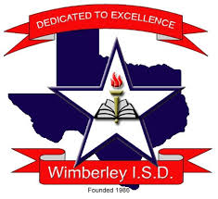

WIMBERLEY HIGH SCHOOL
AFNR
STRATEGIC PLAN
2018-2019
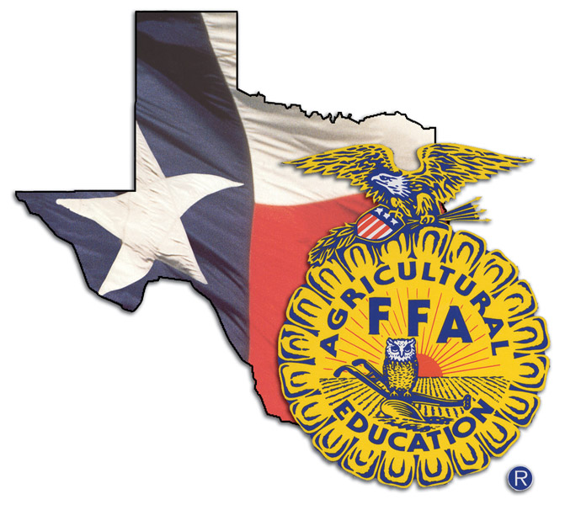

Wimberley High School AFNR Strategic Plan
VISION
Our vision is to create an organization to promote the value and understanding of agriculture as it relates to personal and community growth.

MISSION
Agricultural education prepares students for successful careers and a lifetime of informed choices. Through our three circle curriculum (Classroom, SAE, FFA) students learn life lessons that will help propel them to success.

GOALS
YEAR 1-2
- EVALUATE AND DELEVOPE A COURSE SEQUENCE CONDUSIVE TO STUDENT’S INTEREST AND CERTIFICATION REQUIREMENTS.
  - USE STUDENT SURVEYS TO EVALUATE STUDENT INTEREST.
  - WORK WITH ADMINISTRATION ON CLASS SEQUENCING FROM SURVEY RESULTS.
  - RESEARCH CERTIFICATIONS AND OBTAIN PROPER TRAINING FOR TEACHERS IF NEEDED.
  - HAVE ATLEAST 1 CERTIFICATION OFFERED IN THE AREAS OF AFNR.
    - ANIMAL SCIENCE: BQA/VET TECH
    - FLORAL DESIGN: LEVEL I CERT / KNOWLEDGE BASE CERT
    - WELDING: OSHA 10 HR / AWS D1.1
    - CONSTRUCTION: NCCER CORE / OSHA 10 HR
    - WILDLIFE: HUNTERS ED/BOATERS ED

- WORK TO IMPROVE STUDENT AND PARENTAL INVOLVEMENT AS A WHOLE INCLUDING BUT NOT LIMITED TO: CDE/LDE/STOCK SHOW/SAE AND PRACTICUM.
  - STRESS IMPORTANCE OF PARTICIPATION IN CDE/LDE/STOCK SHOW/SAE AND PRACTICUM EVENTS AS RELATED TO FUTURE SUCCESS.
  - INFORM PARENTS ON THE IMPORTANCE AND BENEFITS THEIR STUDENT CAN RECEIVE BY BEING ACTIVE IN ALL ASPECTS OF AFNR.

YEAR 3-4
- CREATE MORE COMMUNITY INVOLVEMENT THROUGH OUTREACH, COMMUNITY SERVICE PROJECTS, AND NETWORKING TO IMPROVE AWARENESS AND NEEDS OF OUR PROGRAM.
  - BE VISIBLE! PARTICIPATE IN ATLEAST 3 COMMUNITY SERVICE PROJECTS THROUGHOUT THE YEAR.
  - WORK WITH TEACHERS AND STUDENTS AT THE LOWER LEVELS TO HELP PROMOTE AGRICULTURE. HELP STUDENTS HAVE A BROADER UNDERSTANING OF WHERE THEIR FOOD COMES FROM.
  - NETWORK WITH AREA BUSINESSES AND THE CHAMBER TO MAKE A BRAND FOR OUR PROGRAM. ALLOW MORE OPPORTUNITIES FOR STUDENTS THROUGH NETWORKING AND PRACTICUM EXPERIENCES.

- IMPROVE STUDENT SAE PROGRAMS TO BROADEN STUDENT KNOWLEDGE AND ALLOW THEM THE ABILITY TO ACHIEVE MORE OPPORTUNITES FOR SCHOLARSHIPS AND AWARDS.

  - REQUIRE EVERY AFNR STUDENT TO START A RECORD BOOK SAE THEIR FRESHMAN YEAR REGARDLESS OF THEIR INVOLVEMENT IN FFA TO TEACH RECORD KEEPING SKILLS.
  - LOOK INTO POSSIBLE AFFLIATION WITHIN THE FFA ALLOWING ALL STUDENTS ENROLLED IN AFNR CLASSES TO BE FFA MEMBERS AND ELIGIBLE FOR SCHOLARSHIP AND AWARDS THROUGH SAE PARTICIPATION AT THE LOCAL/STATE/AND NATIONAL LEVELS.
  - NETWORK WITH ORGANZIATIONS TO CREATE NEW SAE PROJECTS FOR NON-TRADTIONAL AG STUDENTS.
YEAR 5
- HAVE IN PLACE OFF-SITE PRACTICUM OPPORTUNITIES FOR STUDENTS IN ALL AREAS OF THE AFNR CLUSTER INCLUDING BUT NOT LIMITED TO ANIMAL SCIENCE, WELDING, AND CONSTRUCTION.
  - WORK WITH COMMUNITY AND BUSINESSES IN SURROUNDING AREAS TO CREATE OFF SITE PLACEMENT FOR PRACTICUM STUDENTS.
  - NETWORK WITH CHAMBER TO CREATE RELATIONSHIPS AND BUILD A BROADER NETWORKING GROUP FOR STUDENTS.

OUTCOMES:
There are two outcomes our department wishes from this plan. They are as follows:
- Involvement:
  - Increase the number of students involved in the AFNR program at WHS.
  - Increase the number of community stakeholders involved in promoting our program through community service and practicum opportunities.
  - Increase the knowledge and skills of students through their participation in the three circle model.
  - Increase cross curricular involvement with teachers at all levels.

- Advance Certifications/Awards
  - Increase the number of student certifications to graduating students to better prepare them for the workforce.
  - Increase knowledge of staff through Professional Development to help aid in the offering of advance certifications to students.
  - Increase the number of students receiving awards and scholarships at local/state/ and national levels.

SUMMARY:
As a department we hope we’ll be able to better prepare our students for the ever changing world as they enter into the workforce. We hope this plan will act as a guide in helping our students, parents, staff, and community understand the goals of WHS AFNR and the direction of our program.

